**Project Design Phase-I**

**Solution Architecture**

|  |  |
| --- | --- |
| **Date** | 13 October 2022 |
| **Team ID** | PNT2022TMID42383 |
| **Project Name** | Project - Solution Architecture- Real-Time Communication System Powered By AI For Specially Abled |
| **Maximum Marks** | 4 Marks |

**Solution Architecture:**

Solution architecture is a complex process – with many sub-processes – that bridges the gap between business problems and technology solutions. Its goals are to:

* Discourse and Language Handling is fundamentally worried about the transformation of Discourse to-Text and Text-to-Discourse.
* Text-to-Discourse programming blends composed normal language into a sound result, in straightforward terms it utilizes Regular Language Handling (NLP) innovation to peruse composed text.
* Then again, Discourse to-Text programming does likewise process yet the opposite way around, it combines communicated in language and cycles it into composed normal language utilizing NLP innovation.
* Such programming is many times consolidated in the plans of voice collaborators, programmed discourse acknowledgment (ASR) motors and discourse logical devices.
* Applications that utilization Discourse and Language Handling innovation should have the option to ideal believer and move messages.
* Time, message move and constant show of composed message are a portion of the significant difficulties of switching discourse over completely to message continuously .
* Moment discourse to-message change plans to integrate communicated in language into composed message almost simultaneously.
* This is vital as it would empower individuals living with hearing-impedances to partake in discussions as they would have regularly finished in the event that they were not encountering any conference issues.
* This would empower their discussions to be more captivating as they don't feel like they delayed down interest as a result of getting some margin to handle explanations.

**Example - Solution Architecture Diagram:**

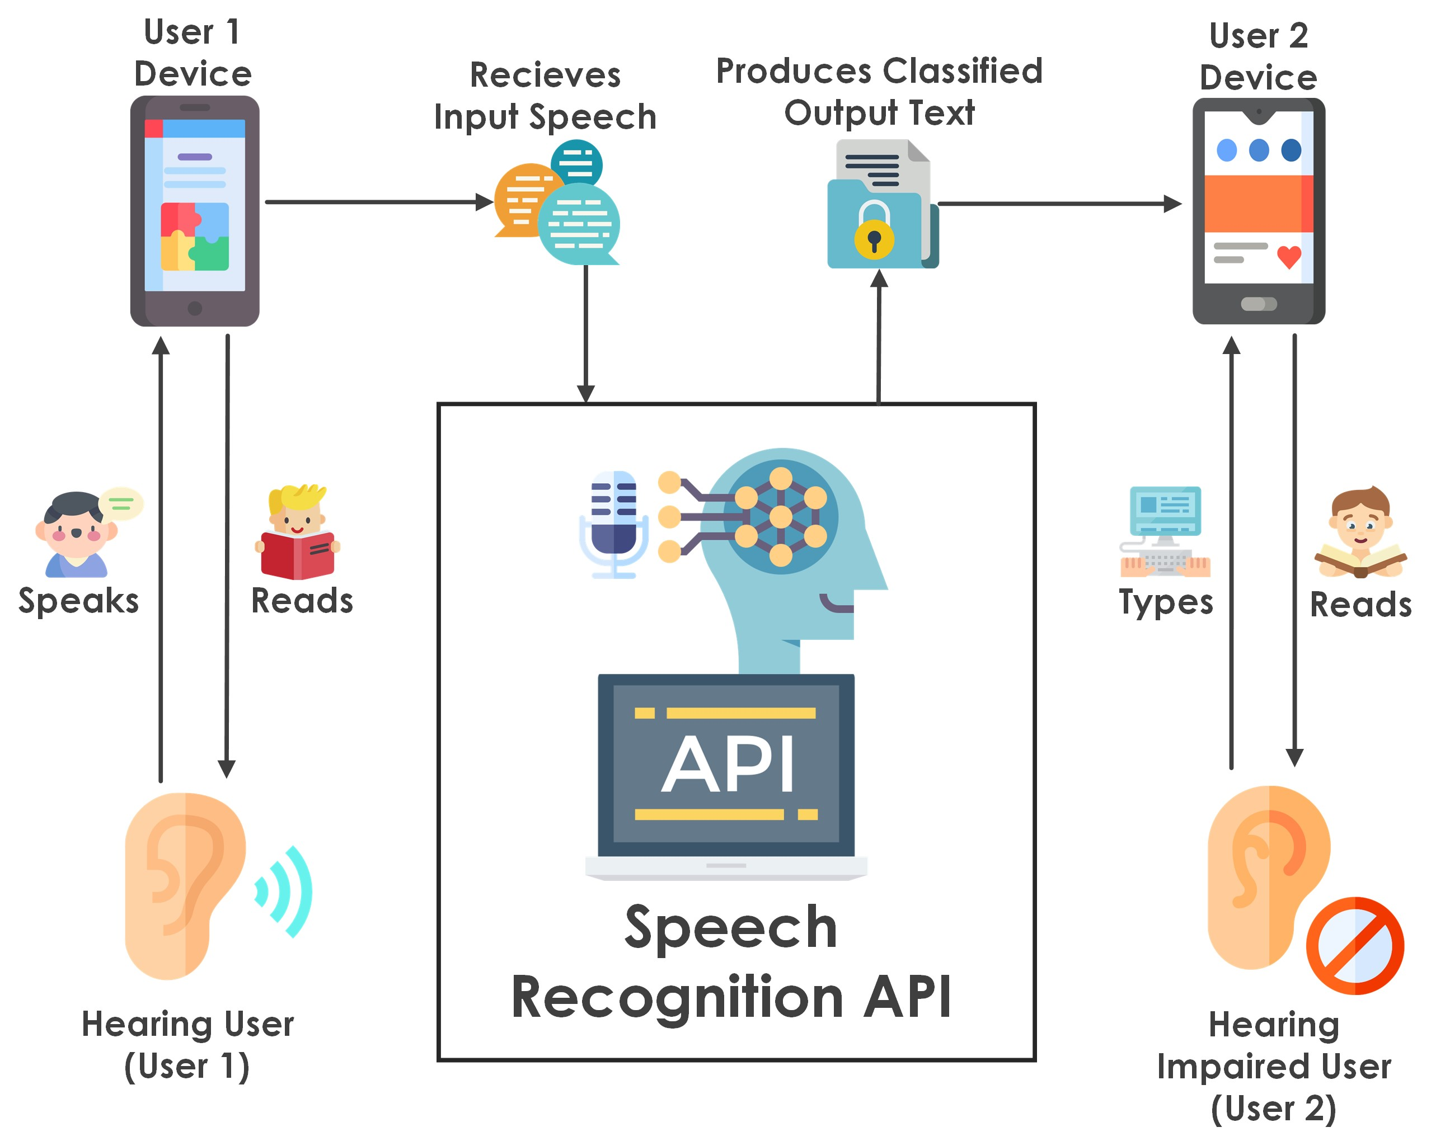

Figure 1: Architecture and data flow of the voice patient diary sample application